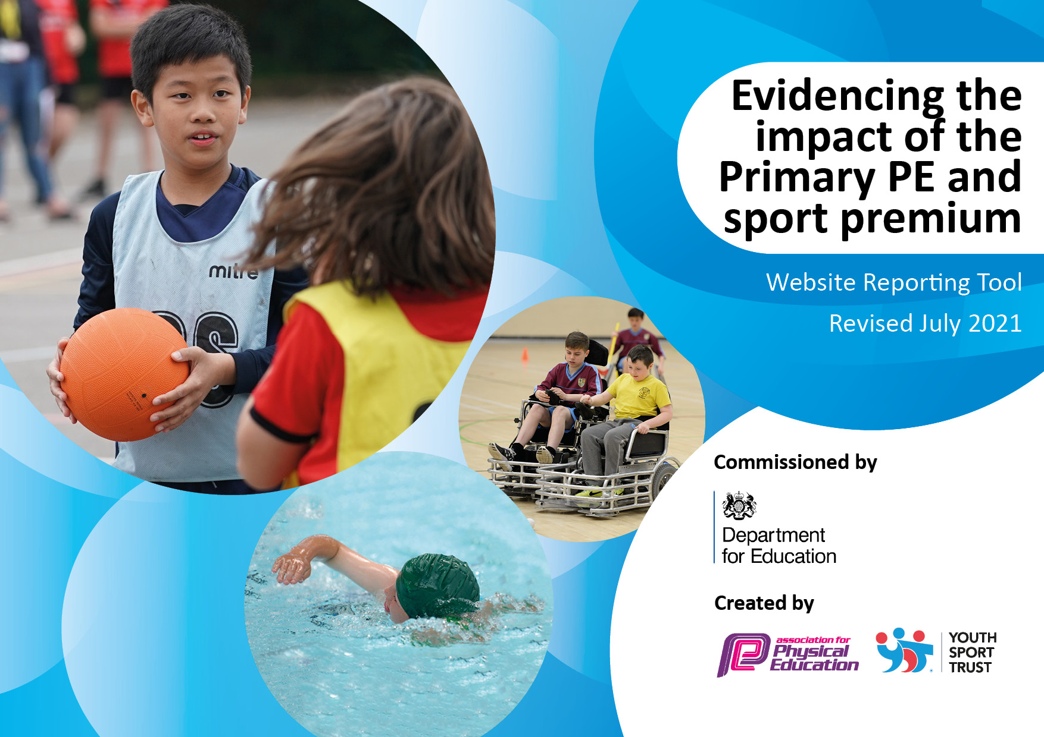
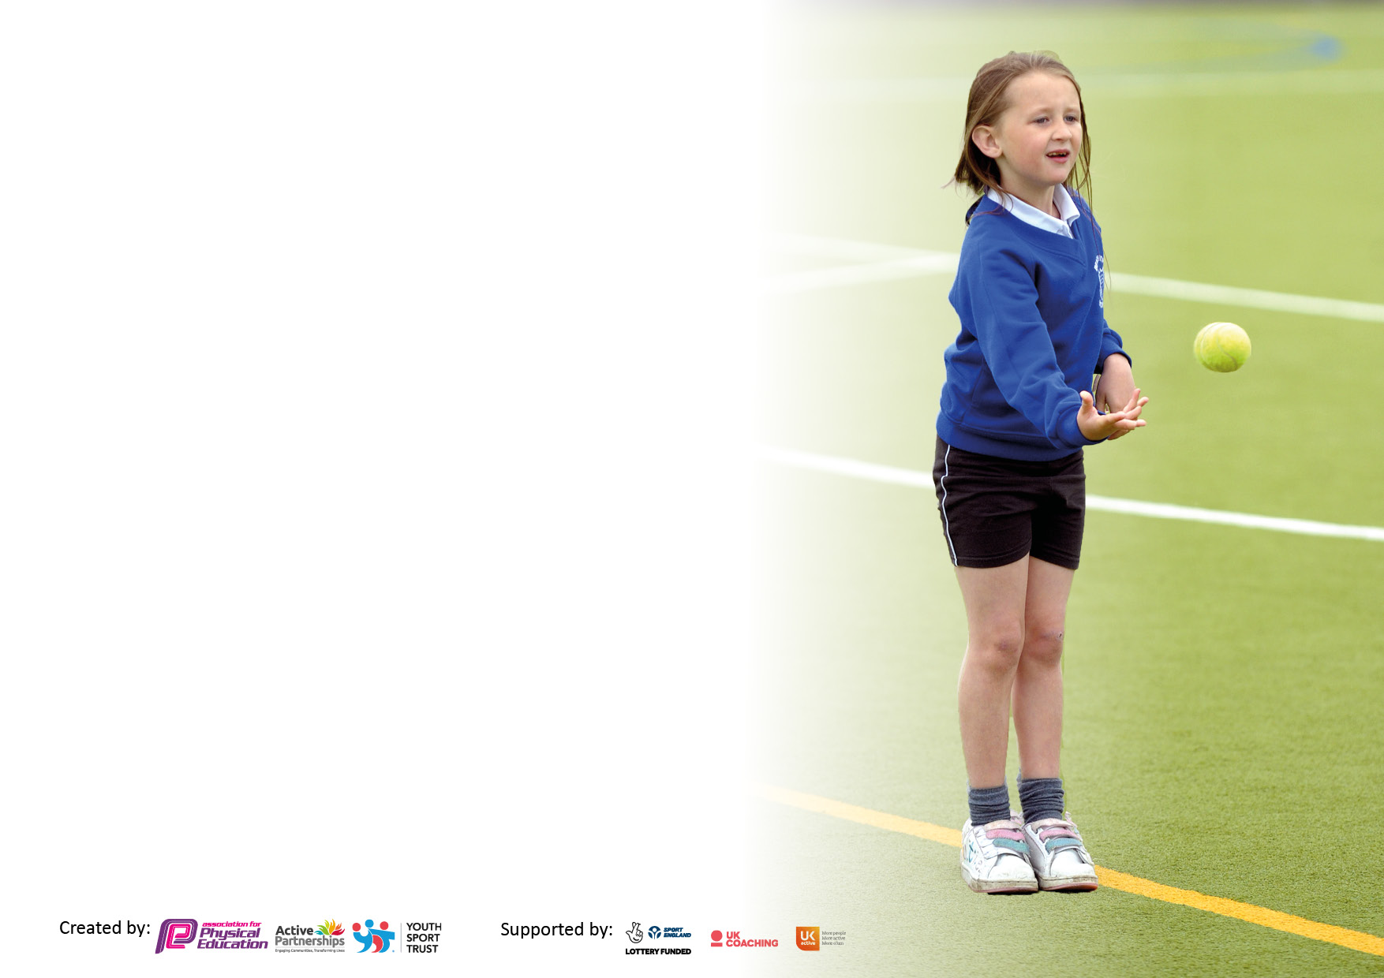

It is important that your grant is used effectively and based on school need. The Education Inspection Framework makes clear there will be a focus on ‘whether leaders and those responsible for governors all understand their respective roles and perform these in a way that enhances the effectiveness of the school’.

Under the Quality of Education Ofsted inspectors consider:
Intent - Curriculum design, coverage and appropriateness
Implementation - Curriculum delivery, Teaching (pedagogy) and Assessment
Impact - Attainment and progress

To assist schools with common transferable language this template has been developed to utilise the same three headings which should make your plans easily transferable between working documents.

Schools must use the funding to make additional and sustainable improvements to the quality of Physical Education, School Sport and Physical Activity (PESSPA) they offer. This means that you should use the Primary PE and sport premium to:

- Develop or add to the PESSPA activities that your school already offer
- Build capacity and capability within the school to ensure that improvements made now will benefit pupils joining the school in future years
- The Primary PE and sport premium should not be used to fund capital spend projects; the school’s budget should fund these.

Pleasevisitgov.ukfortherevisedDfEguidanceincludingthe5keyindicatorsacrosswhichschoolsshoulddemonstrate animprovement.Thisdocumentwillhelpyoutoreviewyourprovisionandtoreportyourspend.DfEencouragesschools to use this template as an effective way of meeting the reporting requirements of the Primary PE and sport premium.

We recommend you start by reflecting on the impact of current provision and reviewing the previous spend.

Schools are required to publish details of how they spend this funding, including any under-spend from 2019/2020, as well as on the impact it has on pupils’ PE and sport participation and attainment. All funding must be spent by 31st July 2022.

We recommend regularly updating the table and publishing it on your website throughout the year. This evidences your ongoing self-evaluation of how you are using the funding to secure maximum, sustainable impact. Final copy must be posted on your website by the end of the academic year and no later than the 31st July 2021. To see an example of how to complete the table please click HERE.

Details with regard to funding
Please complete the table below.

Total amount carried over from 2019/20 | £0.00
Total amount allocated for 2020/21 | £19,950.00
How much (if any) do you intend to carry over from this total fund into 2021/22? | N/A
Total amount allocated for 2021/22 | £20,540.00
Total amount of funding for 2021/22. To be spent and reported on by 31st July 2022. | £20,540.00
Swimming Data
Please report on your Swimming Data below.

Meeting national curriculum requirements for swimming and water safety.

N.B. Complete this section to your best ability. For example you might have practised safe self-rescue techniques on dry land which you can then transfer to the pool when school swimming restarts.
Due to exceptional circumstances priority should be given to ensuring that pupils can perform safe self rescue even if they do not fully meet the first two requirements of the NC programme of study
What percentage of your current Year 6 cohort swim competently, confidently and proficiently over a distance of at least 25 metres?  N.B. Even though your pupils may swim in another year please report on their attainment on leaving primary school at the end of the summer term 2020.  Please see note above | 60%
What percentage of your current Year 6 cohort use a range of strokes effectively [for example, front crawl, backstroke and breaststroke]?  Please see note above | 57%
What percentage of your current Year 6 cohort perform safe self-rescue in different water-based situations? | 44%
Schools can choose to use the Primary PE and sport premium to provide additional provision for swimming but this must be for activity over and above the national curriculum requirements. Have you used it in this way? | No

Action Plan and Budget Tracking
Capture your intended annual spend against the 5 key indicators. Clarify the success criteria and evidence of impact that you intend to measure to evaluate for pupils today and for the future.

Academic Year: 2021/2022 | Total fund allocated: | Date Updated:
Key indicator 1: The engagement of all pupils in regular physical activity – Chief Medical Officers guidelines recommend that primary school pupils undertake at least 30 minutes of physical activity a day in school |  |  |  | Percentage of total allocation:
 |  |  |  | %
Intent | Implementation |  | Impact
Your school focus should be clear what you want the pupils to know and be able to do and about  what they need to learn and to  consolidate through practice: | Make sure your actions to achieve are linked to your intentions: | Funding allocated: | Evidence of impact: what do pupils now know and what can they now do? What has changed?: | Sustainability and suggested next steps:
- Increase the number of KS2 playground leaders to develop greater provision.  - Ensure children with SEN are included in leadership training where appropriate for individual children.  - Give children the ownership and opportunity to plan and organise playground activities and clubs.  - Hear pupil’s voices and adapt opportunities as appropriate.  - Children who are less able physically or less confident so do not participate in physical activity to have support through a targeted intervention group.  - To continue to encourage continued physical activity at home. | - - Year 4 have had training as real leaders through the real Legacy programme of PE.  - Year 5 have had ‘playground leader’ training with Jo Rowe from LSLSSP on Wednesday 26th January. Year 6 children who were trained last year took the lead prior to this.  - We have trained four Year 6 Sports Ambassadors to help support inter-competitions and have a pupil voice.  - - All children across Year 4 are being included in real Leader training through our real Legacy package.  - Children with SEN from Year 5 were asked if they wanted to take part in playground leader training but they did not wish to take part or it was not appropriate.  - - Due to the above, Year 4 children are able to support Year 1 and FS children with their play at lunchtimes through ‘red and yellow bibs’.  - Year 5 children have been able to organise and support their own activities at playtime and lunchtime.  - Sports Ambassadors have led competitions, clubs and games during lunch breaks.  - We have had regular conversations with sports ambassadors and playground leaders about sport and activity within our school.  - - Mr Evans had Big Moves training on 25/11/21 and has been taking a targeted group each term to work with across various Year groups to support their fundamental movement skills, confidence and core strength.  - Mr Evans also had the support of the LSLSSP who have been in to deliver Energise Club which started on 25th October for 8 weeks once a week with this terms group of children.  -The school delivered the Girls Active Lifestyles project, 6 weeks of activity for less active girls in year 5/6. The activity was chosen by the participants. This included dance. The participants also took part in a GALs celebration event at the local leisure centre. The girls took part in a range of activities including bhangra dancing, ultimate frisbee and martial arts. The aim of the event was to signpost the participants to local community exit routes.  -The school delivered the Live Active Do-Sometime project, 6 weeks of activity for less active boys in year 5/6. The activity was chosen by the participants. This included martial arts. The participants also took part in a LADs celebration event at the local leisure centre. The boys took part in a range of activities including boxing, ultimate frisbee and archery. The aim of the event was to signpost the participants to local community exit routes.  The school took part in the SLSSP Big Moves project designed for KS1 pupils who lack fundamental movement skills/physical literacy.  The school participated in the Energise Club/SPARX. The 10 weeks of sessions delivered by SLSSP staff with inactive/less confident Year 3 and 4 (for Energise) or KS1 (for SPARX) pupils. The sessions included fun physical games and mindfulness.  The school took part in an Inclusive Sport Club targeting SEND pupils. A coach from SLSSP delivered a 6 week club alongside a member of staff.  The whole school took part in the Move It March project. Each child was given a physical activity tracker to fill out during March 2022. Certificates and prizes were awarded to children who achieve physical activity milestones (250 active minutes=Bronze, 500 active minutes=Silver, 750 active minutes=Gold and 1000 active minutes=Platinum). Pupils were also given points for achieving milestones and the most active class won a trophy.  - - Teachers and parents have been reminded via email to encourage children to use their real PE at home log ins, particularly when self-isolating as a means of doing exercise in the home.  - We have also participated in the ‘Move It Boom’ competition through Active Together (LRS). This encouraged children to stay active and to log their exercise via an online log in. Parents and teachers were regularly updated to encourage participation.  - We also send home various resources and opportunities such as ‘The festive fun active at home’ booklet at Christmas, student and staff well-being challenges such as the summer common wealth game challenge, free tickets to the LCCC, external inclusive club lists and well-being newsletters from the LSLSSP. | £2650 to LSLSSP for membership fee. | Playground leaders have been delivering clubs and games that they have planned themselves to children across the school at lunch and have been organising the play equipment at break and lunch meaning playtime and lunch time is more active and has structured activities taking place.  Sports ambassadors have led internal competitions and have also led virtual competitions with most children from KS1 and KS2 meaning more children have been able to take part in competitive sport and are better prepared for external competitive opportunities.  Year 4 children are better prepared to become playground leaders as they move into Year 5.  We spoke with the playground leaders and sports ambassadors about PE and sport provision in school and have added girls football clubs and other competitive opportunities and clubs such as a skipping club at lunch time based on their feedback.  In the autumn term Mr Evans worked on physical movement skills with Year 5 and 6. In the spring he worked with Years 3 and 4.  In the summer it was Year 1 and 2.  The children were chosen in discussion with the class teachers, SENCo, Mr Evans and Miss Benjamin.  In the Autumn, 5/6 children made progress with one child increasing from being able to do 4 skills to all 12.  All children from the GALs intervention attended a dance showcase and performed for a large audience with children from other schools through the dance company who ran the intervention.  One child from the LADs intervention has gone on to attend martial arts classes with the instructor outside of school. All boys that attended have gained confidence from taking part.  All 455 children took part in ‘Move it March’ and 290/455 children active travelled during ‘Move it March’. 4EB were the most active class.  We came 20th out of over 130 schools by the end of the Autumn term in the Move It Boom competition.  Parents have informed us that they have taken up various sporting opportunities outside of school based on our emails such as attending LCCC and going to common wealth games events and inclusive clubs. | Gain a better uptake of children with SEN taking part in leadership training.  Continue to teach ‘real Leaders’ in Year 4 and train Year 5 playground leaders and Year 6 Sports Ambassadors via the LSLSSP.  Carry out pupil interviews to hear a wider pupil voice and adapt provision based on feedback.  Continue to take part in GALs, LADs, Big Moves and all other provisions from the LSLSSP aimed at targeted intervention groups.  Begin to use ‘real Play’ at home or similar resources to encourage more activity at home with targeted families.
Key indicator 2: The profile of PESSPA being raised across the school as a tool for whole school improvement |  |  |  | Percentage of total allocation:
 |  |  |  | %
Intent | Implementation |  | Impact
Your school focus should be clear what you want the pupils to know and be able to do and about  what they need to learn and to  consolidate through practice: | Make sure your actions to achieve are linked to your intentions: | Funding allocated: | Evidence of impact: what do pupils now know and what can they now do? What has changed?: | Sustainability and suggested next steps:
- To monitor the implementation of the curriculum and support where necessary by ensuring PE is taught using a consistent approach and progression from Foundation Stage through to Year 6.  - Continue to promote PE and physical activity using both physical and electronic communications.  - New team kits to be purchased to replace older ’worn out’ kits as needed.  - The school continues to promote active travel through school newsletters and social media. The school with closely with the Leicestershire County Council Officer to promote Active Travel including encouraging parents to park and stride.  - Continue to update PE and breaktime equipment, as necessary.  - To engage student voice and use student leaders to raise the profile of PE and School Sport as well as the link between exercise and mental health through utilising the wellbeing and sporting ambassadors training provided by the LSLSSP.  - To achieve the bronze accreditation on Modeshift STARS. | - - Miss Benjamin completes termly lesson observations of Mr Evans.  - Miss Benjamin has regular discussions and meetings with teachers regarding PE and supports where necessary.  - Teachers are present in all PE lessons and are able to learn from Mr Evans during the outdoor lessons he delivers to their classes through ongoing instruction and observation.  - - The twitter page has been regularly updated with information and photographs about matches, competitions, clubs, fundraising, and any other PE related activities.  - Our school newsletter has contained information on physical activities, competitions, sporting opportunities and clubs.  - The PE noticeboard has been regularly updated with resources and tools for learning in the school hall.  - We have also sent emails to class teachers with lunch time opportunities and results from competitions to share with their class.  - Sporting achievements were also celebrated sport in assemblies with many children doing match reports following competitions.  - Unfortunately, the budget has not allowed for us to update the team kits this academic year. We purchased one waterproof jacket and whistles for staff who support competitions and clubs.  - In October 2021, the whole school took part in active travel month. We also entered the school banner competition.  - We purchased a new parachute for KS1 and bought swimming resources from Swim England. Unfortunately, the budget has not allowed for us to update more equipment, however we are well stocked and check that all equipment is safe regularly.  - - 4 students from Year 5 and 6 completed well-being ambassador training on 16/11/21 and have been supported by our PSHCE leads, Miss Scott and Miss Hageman to implement a plan to support children’s wellbeing across the school.  - 4 Year 6 students completed Sports Ambassador training on 8/10/21. Miss Benjamin and Mr Evans speak with the sports ambassadors and ask them to run the virtual competitions, encouraging all children to take part.  - We also send home the well-being newsletters provided by the LSLSSP with our school newsletters via parentmail.  - Following lockdown students struggle to focus for long periods of time so SLSSP devised some easy to implement 5 minute brain and active breaks. We also used websites like ‘go noodle or ‘BBC supermovers’.  - We have worked closely with Dee Stevens from Modeshift STARS to promote active travel and achieve the accreditations. Miss Benjamin met with her on 10/2/22 and created an action plan which has been worked on throughout the year. | £14,373.19 towards funding our sports coach.  £23.62 for staff equipment.  £89.59 for a new parachute.  £43.60 for swimming resources. | Miss Benjamin has observed Mr Evans teaching Year 1 and Year 2 and has visited all other Year groups.  Miss Benjamin has supported teachers with the planning and delivery of real PE. Miss Benjamin discussed a sequence of lessons with a Y2 teacher and then taught the class whilst the teacher observed.  The whole school took part in active travel month in October 2021. 45.62% of children actively travelled for 11 days or more during October. 75% of pupils said they would sustain travelling actively in the future. 4EB was the most active class. A Year 6 child one the school banner competition to promote active travel and this has been place on our gates outside of school for all to see.  The Wellbeing Ambassadors have worked on three initiatives across the year: kindness jars to promote kindness and spread kind messages within the classroom; encouraging children to be aware of their digital wellbeing by creating posters encouraging others to spend less time online and go outside more and have created question sheets for new teachers to aid pupils’ transitions to the next year group.  The sports ambassadors have also created posters to promote the competitions and clubs they have been running which led to higher uptake. They also supported Children’s Mental Health Week by creating posters and by raising awareness by speaking about it in all classes in the school.  We have achieved the ‘Green Award’ through Modeshift STARS for our efforts with Active Travel. We have set up a ‘Park and Stride’ route starting from our local pub ‘The Grange’. We had a launch day on17th March 2022 where over 100 parents and children attended. We were very close to bronze but needed to complete a survey to gain this accreditation.  We have achieved the Gold award for the School Games Mark.  The brain and active breaks allowed mental refocus and the opportunity to expel some energy. There was a cross-curricular theme. | New team kits to be purchased to replace older ’worn out’ kits as needed.  Update PE and breaktime equipment as necessary.  To achieve the bronze accreditation for Modeshift STARS.  The lunch time supervisors to be trained to put on a range of activities/games during lunch. The lunchtime supervisors could create zones to ensure a variety of activities can take place during lunch. The Playground Leaders will continue to put on a lunch time club for KS1 children.

Key indicator 3: Increased confidence, knowledge and skills of all staff in teaching PE and sport |  |  |  | Percentage of total allocation:
 |  |  |  | %
Intent | Implementation |  | Impact
Your school focus should be clear | Make sure your actions to | Funding | Evidence of impact: what do | Sustainability and suggested
what you want the pupils to know | achieve are linked to your | allocated: | pupils now know and what | next steps:
and be able to do and about | intentions: |  | can they now do? What has
what they need to learn and to |  |  | changed?:
consolidate through practice:
- Our two-year next steps package with real Legacy allows us to have more in school support, CPD and access to online resources to support the continued development of teaching and learning in PE.  - Provide dance training to staff to boost confidence in delivering dance in the curriculum.  - Provide further training on PE assessment and create systems to use so that both indoor and outdoor PE can be assessed and inform teaching next academic year.  - Complete a Staff survey again to see if/where teachers feel they now need support. | - - All staff received training on how to assess using the real PE assessment wheel on 6/12/21.  -Year 4 classes had two lessons of real Leaders taught to them by Neil from Create whilst teaching staff observed on 6/12/21.  - on 26/6/22 – All staff received training in real Dance.  2. - Year 5 had dance lessons delivered by a qualified dance instructor from Core Dance Company during Autumn term 1 and Year 3 during Autumn term 2.  - on 26/6/22 – All staff received training in real Dance.  3.- See point 1  - Mr Evans is using our assessment system, DCPro, to assess outdoor PE at the the end of a unit of work, using the skills progressions to inform these decisions.  - Our PE co-ordinator has taken part in local PE Subject Leader meetings. The PE Co-ordinator shared the learnings with all colleagues during staff meetings  - Our sports coach took part in the Leicestershire and Rutland PE Conference, taking part in a variety of workshops including AFPE assessment in PE, the role of the PE coordinator and outstanding PE, sport and well-being workshop. The PE Co-ordinator shared the learning points with all staff.  - Staff have taken part in a survey that was conducted by the LSLSSP in the Autumn term. | £2495.00 for continued provision from Create Development who provide our real Legacy PE package.  £865.00 to the ‘Core Dance Company’ for dance lessons. | All teachers are now assessing in PE every half term on the PE wheel. Mr Evans is also assessing outdoor PE half termly and children are making progress but we have noticed that more girls are working below in PE than boys across the school.  In the staff survey, all of the teachers agreed or strongly agreed that they enjoy teaching PE, they think PE is important and they feel confident to teach it. Except one Year 5 teacher that said they neither agree nor disagree that they feel confident. | Going forward, there needs to be even more focus on and promotion of girls in sport.  We have invited in a female athlete at the beginning of next academic year to promote a love of sport and exercise in girls and have already begun to seek guidance from ‘Totally Runable’ as to how we can raise the profile of girls in sports and PE.  If the budget allows, it would be beneficial to pay for Totally Runable to come in to school and support us to get more girls involved in PE and sport.  Continue to monitor teacher confidence and CPD needs.  SLT will continue to champion the PE co-ordinator role. The PE co-ordinator will deliver whole school staff workshops. The PE Co-ordinator will also survey staff to highlight areas of PE where further CPD is needed.
Key indicator 4: Broader experience of a range of sports and activities offered to all pupils |  |  |  | Percentage of total allocation:
Intent | Implementation |  | Impact
Your school focus should be clear | Make sure your actions to | Funding | Evidence of impact: what do | Sustainability and suggested
what you want the pupils to know | achieve are linked to your | allocated: | pupils now know and what | next steps:
and be able to do and about | intentions: |  | can they now do? What has
what they need to learn and to |  |  | changed?:
consolidate through practice:
Provide all pupils with a broad and balanced PE curriculum and school sport offer, which includes alternatives to traditional sport by:  - Continuing to seek external providers and opportunities for children.  - Continuing to make links with local providers and signpost children to relevant opportunities and clubs.  Additional achievements:  The children have taken part in the Santa Dash organised by the LSLSSP to raise money for the Trussell Trust on 10/12/21.  We have four children trained as Sports Ambassadors and four as well-being Ambassadors.  We also took part in the Return to Sports Festival organised by the LSLSSP to celebrate the return to face-to-face sport and encourage children to take part in a non-competitive way.  Large choice and uptake of pre and after school sports and activity clubs.  Increased use of play equipment at lunchtimes – more active children.  Increased number of lunchtime competitions.  Offering all children at least 30 minutes of physical activity a day, either at break and lunch time or through sports clubs. | - - The core dance company have worked with Year 3 and 5.  - Superstar Sport Midlands have been into school w/c 13/12/21 to deliver free lunchtime sessions to KS2 children  - - Sports Cool came in on the 10th and 11th/3/22 to work with KS1 and KS2 delivering tri-golf and archery for free.  - We have sent home a variety of leaflets to clubs and sporting opportunities via parent mail such as Football Fitness for their Christmas holiday club and the LSLSSP newsletters and at home activities. We have also sent home a list of inclusive clubs for children to join outside of school. We also offer our own holiday clubs run by our sports coach in most school holidays.  We have also engaged in various sports related competitions such as the design a sports baton competition for the Common Wealth Games.  Our school took part in the FA’s Girls Football week. This included virtual football challenges for girls and a design a football competition. The ideas of the week was to raise the profile girls football and increase participation.  Mr Evans, our sports coach has also completed Disney Shooting Stars Training accredited by England Football and is running a football club for girls at lunch time. The girls have also taken part in the local girl’s football competition. |  | A child in Year 5 won both the design competitions and has had her baton design turned into a real baton. She has one to keep, as does the school and one is being used in the Common Wealth Games.  Parents have informed us that they have taken up various sporting opportunities outside of school based on our emails and opportunities provided in school such as attending LCCC and going to common wealth games events and inclusive clubs.  We have also had a visibly higher uptake of girls playing football across the school both in clubs but also during playtimes and lunchtimes.  The Year 6 girl’s football team won the local Danone cup. The Year 3 and 4 girls attended a football festival.  There are children from all year groups including foundation stage attending before and after clubs such as mini wheelers, basketball, dodgeball, gymnastics, dance, musical theatre, multi-skills and many more. We have a total of 451 places being taken by children attending clubs for this academic year. | Seek more opportunities from external providers within school and continue to signpost children to local providers and opportunities outside of school.

Key indicator 5: Increased participation in competitive sport |  |  |  | Percentage of total allocation:
 |  |  |  | %
Intent | Implementation |  | Impact
Your school focus should be clear | Make sure your actions to | Funding | Evidence of impact: what do | Sustainability and suggested
what you want the pupils to know | achieve are linked to your | allocated: | pupils now know and what | next steps:
and be able to do and about | intentions: |  | can they now do? What has
what they need to learn and to |  |  | changed?:
consolidate through practice:
- The school will continue to take part in competitions via a blended approach of both virtual and face to face competitions. The school is committed to taking part in the local competitions.  - Continue to provide more internal competitive opportunities for KS1 children. | - We have taken part in a variety of competitions, both virtual and in person such as the virtual 5km, football tournaments for the Danone Cup, Sports Hall Athletics and a Table Tennis Competition.  - We have taken part in the KS1 virtual bean bag balance during Autumn term 2. They have also taken part in the KS1 relay race.  Mr Evans and teachers have organised participation in the above virtual opportunities during both PE lessons and lunchtimes. |  | The Year 6 boys football team got through the final of the local league.  Our Year 3 and 4 virtual 5km teams came in the top 10.  We also had children place in the top 10 in cross country.  Our Year 6 girls football team were among the top 8 teams in Leicestershire.  Our girls team came second place in the county finals of the table tennis competition.  Our boccia and new age kurling teams won their competitions.  Our Year 3 and 4 dodgeball team won their competition.  As did our Netball team and our Year 5 and 6 tennis team, who went on to be county runners up.  The whole school has taken part in virtual competitions meaning KS1 have had more opportunities to take part competitively than previous years.  Year 1 and Year 2 took part in the free throw challenge. Year 2 took part in the KS1 relay race. | The school will continue to take part in competitions next academic year. SLSSP will promote a blended approach next year, both virtual and face to face competitions will take place. The school is committed to taking part in the local competitions.

Signed off by
Head Teacher:
Date:
Subject Leader:
Date:
Governor:
Date:

