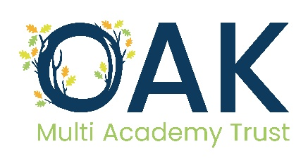

**Subject Access Request – Requester Guide**

DATE: 19 November 2024

# Subject Access Request – Requester Overview

As an organisation we collect and process data about individuals. We explain what information we collect, and why, in our Privacy Notices.

Any individual, person with parental responsibility, or young person with sufficient capacity to make a request, is entitled to ask what information is held. So that person is the ‘Requester’.

Copies of the information may also be made available on request. A form to complete is available (see Appendix 1, or on the Trust website).

To ensure that requests are dealt with in an effective and timely manner we may seek to clarify the terms of a request.

To collate and manage requests each school will have an individual allocated to co-ordinate all requests. Please contact [admin@oaktrust.org](mailto:admin@oaktrust.org) for further information or download the Subject Access Request form on our website.

# What happens next?

There is a SAR request form on the Trust website. We encourage everyone to use this form as it enables us to make sure you are being provided with the actual information that you require. Please complete the form, and provide the necessary information, and send it back ***to the relevant school office.***

Evidence of the requester’s identity may be required. Discretion about employees and persons known to the school may be applicable but if ID evidence is not required an explanation must be provided by school staff and signed and dated accordingly.

We may need to contact you to clarify details about what you have requested.

We may need to contact other people and 3rd parties, who have provided information that is on our files.

# Providing the Information

We need to review the information to see what can be shared, or if any item needs another person’s consent. It may be that some information is subject to an exemption and cannot be shared.

Exemptions to a SAR exist and may include:

* Education, Health, Social Work records
* Examination marks and scripts
* Safeguarding records
* Special educational needs
* Parental records and reports
* Legal advice and proceedings
* Adoption and Court records and/or reports
* Regulatory activity and official requests e.g., DfE statistical information
* National security, Crime, and taxation
* Journalism, literature, and art
* Research history, and statistics
* Confidential references

All data subjects have the right to know:

* What information is held?
* Who holds it?
* Why is it held?
* What is the retention period?
* That each data subject has rights. Consent can be withdrawn at any time (to some data).
* A right to request rectification, erasure or to limit or stop processing
* A right to complain

Much of this will be contained within the Privacy Notices and other information on our website.

**Provision and Timeline**

The information will be provided in an electronic format, usually within one calendar month of the request. However, in some circumstances if the request is complex or it is difficult to access the information, this may be extended by up to another 2 calendar months.

Information is usually provided in a secure electronic format.

Following delivery of the information the requester has the right to ask for a review or use the complaint process if they feel that information has not been provided.

Appendix 1

Subject Access Request Form

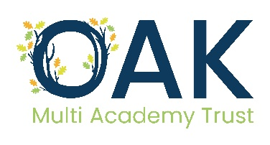

Subject Access request Form

*Please return this form to the relevant school office*

You should complete this form if you want us to supply you with a copy of any personal data we hold about you or the person for whom you are making this request. You are currently entitled to receive this information under the Data Protection Act 2018 (DPA) and the UK General Data Protection Regulation (GDPR).

We will also provide you with information about any processing of your personal data that is being carried out, the retention periods which apply to your personal data, and any rights to rectification, erasure, or restriction of processing that may exist.

By law, information will be disclosed to you within one calendar month of receipt of your request. In some circumstances, this timeframe can be extended up to a further two months. If this applies in your case, you will be informed within the first calendar month.

There are some occasions when we will seek further clarification from you to enable us to comply with your request. Where this is the case, the calendar month timeframe is paused until clarification has been received.

The information you supply in this form will only be used for the purposes of identifying the personal data you are requesting and responding to your request. You are not obliged to complete this form to make a request but doing so will make it easier for us to process your request quickly.

The person who the personal data is about is known as the data subject and the person who is making the request is known as the applicant. These can of course be the same person depending on the personal data sought. If you are a parent seeking access to your child’s official educational records, please contact the school office. The information you provide on this form will be used only for the purposes of processing your request.

| Section 1 | |
| --- | --- |
| Name: | Surname: |
| Name of School  Relationship with the school  Please select:  Pupil / parent / employee / governor / volunteer  Other (please specify): | |
| Correspondence address | |
| Contact number | |
| Email address | |
| I am the data subject (please tick)  Yes (go to section 3)  No (go to section 2) | |

| Section 2: Details of the data subject | |
| --- | --- |
| Name: | Surname: |
| Address: | |
| Date of birth: | |
| Year group (if applicable) | |
| Contact Number | |
| Email | |

| Section 3: Details of information being requested |
| --- |
| Please provide a clear description of the information you are requesting including, dates, departments and/or any additional information which will enable us to locate it (continue on a separate sheet if needed). |

| Section 4: Proof of Identitiy / consent |
| --- |
| Please send us copies of two documents that prove who you are.  € **One must be photographic (such as a valid passport or driving license) and**  € **One must prove your current address (such as a recent electricity bill, or council tax bill).**  Alternatively, if you are in regular contact with the school, you may wish to arrange an appointment to confirm identification in person.  However, proof of address will be required regardless unless collection of information will be in person also.  Please tick either: -  € **The information requested is about myself.**  € **I am the parent / guardian requesting access to my child’s personal data.**  (Please note that written consent is required if your child is the age of 13 or over.)  € **I am representing another individual**  In addition to the required identification outlined above, please send us two forms of identification and written permission from the person that the information is about, saying that we can give you their information. Please note that in some circumstances we may need to verify authenticity. |

|  |
| --- |
|  |

| Section 6: office use only | | |  |
| --- | --- | --- | --- |
| Receipt Date: |  | Received by: |  |
| ID required/received: |  | Proof of address required/received: |  |
| Reference: |  | Oak Trust informed: |  |